**Requirement Documentation**

**In Scope**

* **Client module -** This Create Ticket Module can create ticket that will be use for transaction with the company and View Ticket for clients which will able them to see the progress of the issue they sent.
* **Ticket Module –** This module enables the administrator and the users to view the open tickets, the assigned tickets, closed tickets and those that are pending. In this module where they make the progress of the tickets.
* **Maintenance Module –** This module is accessible only by the administrator. In this module the administrator can add, edit and delete status, severity and resolution.
* **Users Module –** This module is accessible only by the administrator. In this module the administrator can add, edit, and delete user accounts for the system. The administrator also can activate and de-activate the user accounts.
* **Report Module –** The Reporting Module was designed to provide a feature-rich and user-friendly web interface for managing reports. The core idea behind the Reporting Module is to provide a solid foundation so that other developers can use the framework to implement new features.

**System Design**

1

Start Progress

Ticket Details

Client

Create

Ticket

On going

Notify Ticket

D1 Tickets

2

Fix Bug

Progress

Resolution Ticket Status

D2 Tickets

3

Verify if Fixed

Fixed

**Development and Testing**

To be able the gather the relevant information in the study, the researcher made use of iterative model methods is that they all focus on empowering people to collaborate and make decisions together quickly and effectively. Iterative model continuous planning, continuous testing, continuous integration, and other forms of continuous evolution of both the project and the software, where the proposed of the software or the system should be determined.

**Description of the Prototype**

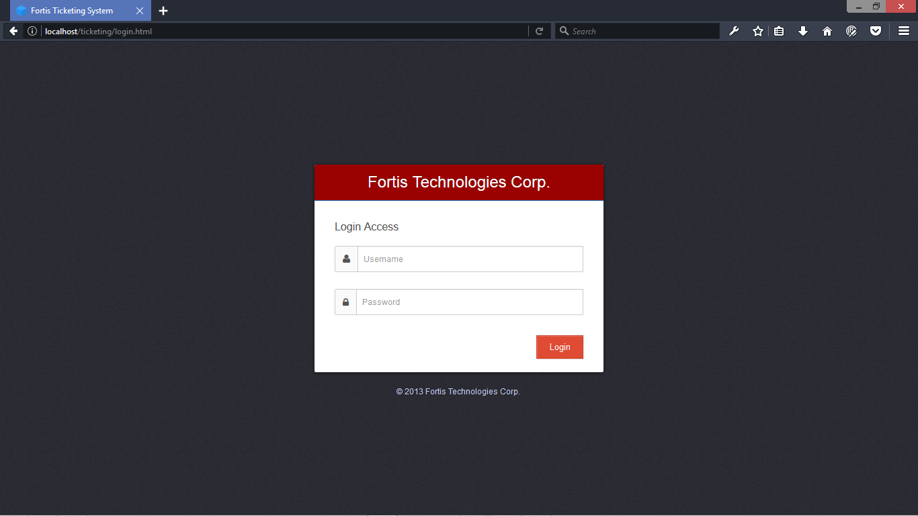

**Login Form -** This page is used to open a session with an account that is already created.

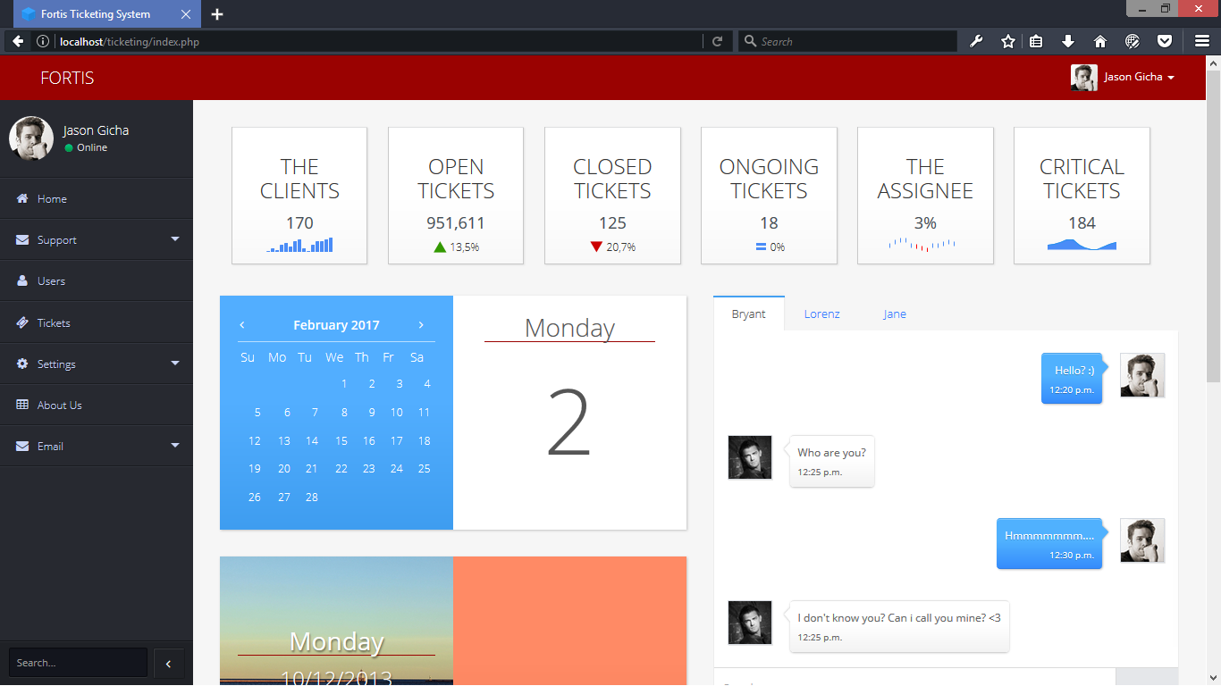

**Admin Index -**This Admin Index Module will use to see and to manage the system.

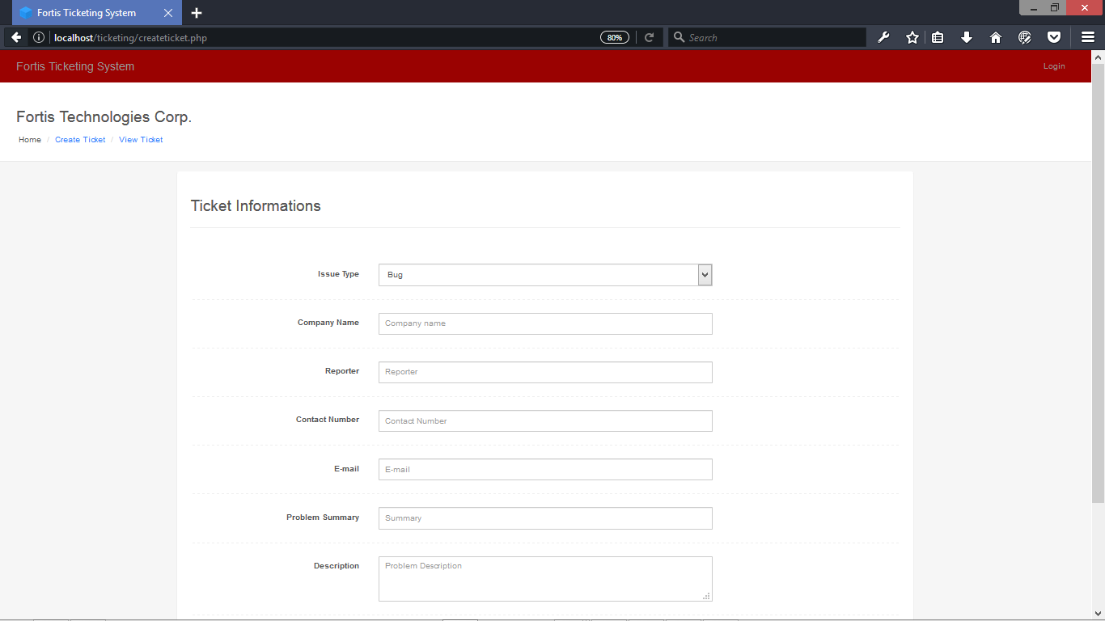

**Create Ticket -** This Create Ticket Module can create ticket that will be use for transaction with the company

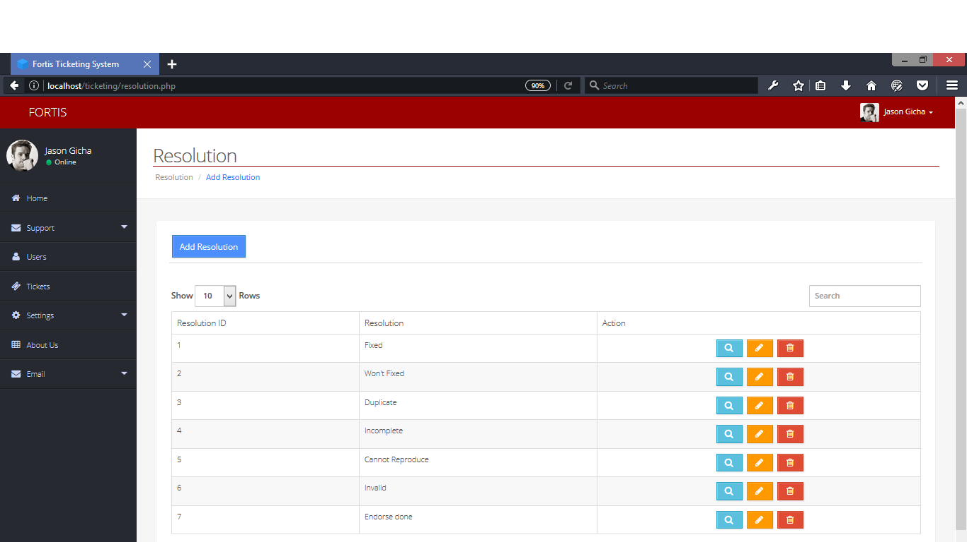

**Setting Resolution -** This Setting (Resolution) Module can add, edit, and delete resolutions.

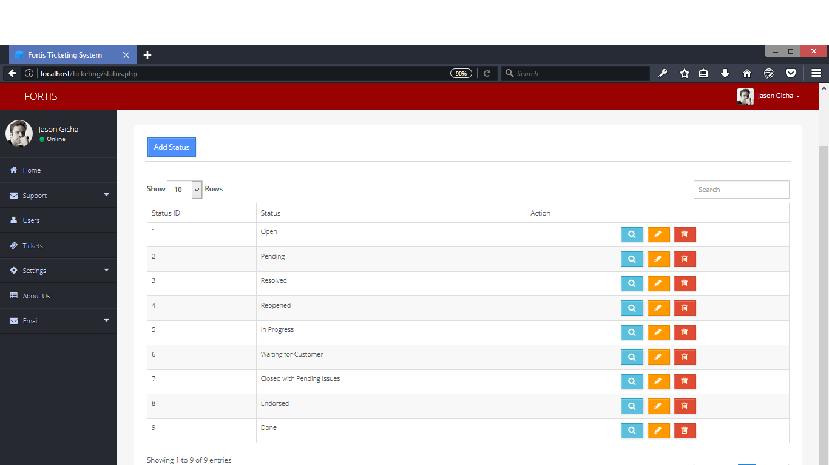

**Setting Status -** This Setting (Status) Module can add, edit, and delete status.

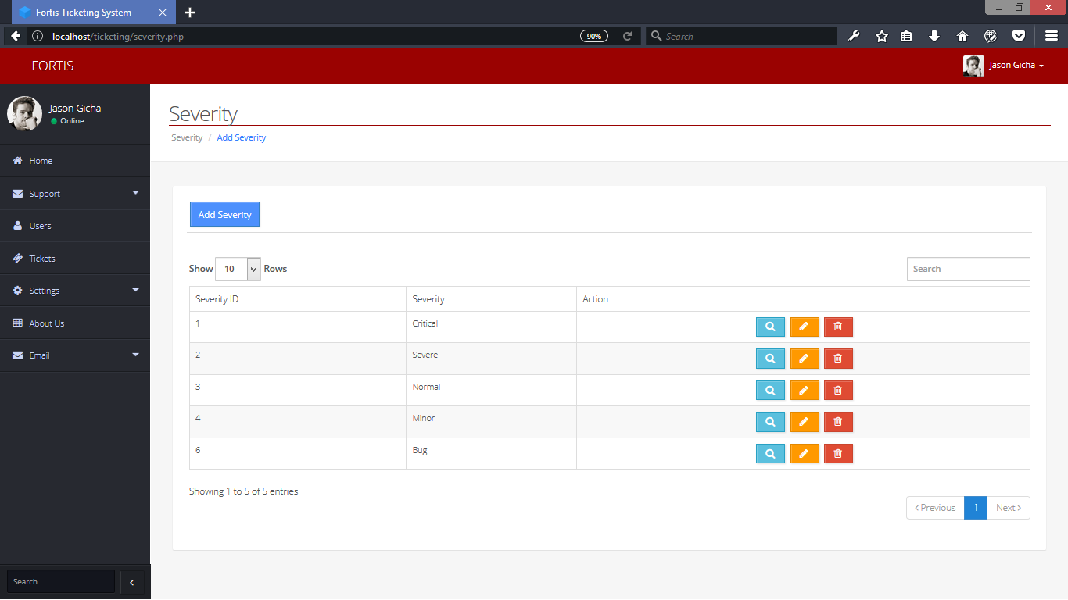

**Setting Severity -** This Setting (Severity) Module can add, edit, and delete severity.

**Implementation plan**